**Tissue damage**

**09-17-20**

**Article:** Jin-Combining experimental and mathematical modeling to reveal mechanisms of macrophage-dependent left ventricular remodeling-BMC systems biology

Based on the size of damage site TGF-β activated (by an input signal uT). TGF-β recruit macrophage and fibroblast. Fibroblast deposit collagen.

**Figure:** Macrophage migration rate M(Tβ), fibroblast growth rate Fg(Tβ), and fibroblast secretion rate Fc(Tβ) plotted as functions of TGFβconcentration.

Assuming baseline = 0, followings are the function for macrophage migration, fibroblast recruitment and secretion.

and follows the dynamics. But $F_{C}\left(T_{}\right)$ don’t match experimental observation even with baseline value.

$uT$**is the input signal from damaged site**

The activation function peaked at 15, 30, and 60 pg/μL/day, according to active expression levels observed in small, median, and very large infarcts, respectively peaked at day 2, and returned to normal levels after day 7 in mice post-myocardial infarction

**Simplified ODEs**

$$\frac{d[M]}{dt}=M\left(T_{}\right)-d_{M}[M]$$

$$\frac{d[F]}{dt}=k_{F}F_{g}\left(T_{}\right)-d_{F}[F]$$

$$\frac{d[T_{}]}{dt}=k_{MT}\left[M\right]+k_{FT}\left[F\right]+uT-d_{T_{}}[T_{}]$$

$$\frac{d[C]}{dt}=k_{FC}{[F]F}_{C}\left(T_{}\right)$$

**Table: List of parameters**

|  |  |  |
| --- | --- | --- |
| **Symbol** | **Biological meaning** | **Value** |
| $$d_{M}$$ | Macrophage removal rate | 0.6 day-1 |
|  | Fibroblast growth rate | 0.924 day-1 |
|  | Fibroblast apoptosis rate | 0.12 day-1 |
|  | Macrophage TGF-β production rate | 0.07 pg/cell/day |
| $$k_{FT}$$ | Fibroblast TGF-β production rate | 0.004 pg/cell/day |
| $$d_{T_{}}$$ | TGF-β degradation rate | 15 day-1 |
|  | Fibroblast collagen production rate | 20 μg/cell/day |

**Simulated result for constant supply of $uT=15 pg/$ μL/day**

**Agent based model**

* Start from an immune model where tissue is not completely destroyed (faster T recruitment and faster T kill)
* When CD8+ T cell kills an infected cell that location of infected cell will become the source point for secretion of anti-inflammatory cytokine (source term uT)
* Anti-inflammatory cytokine will diffuse
* Recruitment of fibroblast depends on the concentration of anti-inflammatory cytokine ($k_{F}F_{g}\left(T_{}\right)$)
* Fibroblast chemotaxis towards the source of maximum secretion source of anti-inflammatory cytokines
* Fibroblast deposit collagen in the damages site $k_{FC}{[F]F}_{C}\left(T_{}\right)$

**Faster T recruitment:** We also increased the recruitment rate of CD8+ T cells to the tissue in response to inflammatory cytokines by reducing 𝜌min from 0.4 to 0.1, and by reducing 𝜌sat from 0.7 to 0.4

**Faster T kills:** the rate of CD8+ T cell killing was doubled by reducing the threshold contact time for cell death from 50 min to 25 min

**Multiplicity of infection (MOI):** change MOI from 0.1 to 0.01

* Anti-inflammatory cytokine
* Diffusion coefficient $555.56 μm^{2}/min$
* Fibroblast
* Cell migration rate along damaged tissue life in voxel: $1 μm/min$?

Decay rate can be estimated from the ODEs

**PhysiCell Implementation**

**In epithelium_submodel.cpp line 183**, I have added condition for secretion of anti-inflammatory cytokines while killed by CD8+ T cells. But probably this is applied only at one time point instead of constant supply

**Setting anti-inflammatory secretion rate = 100**

**Orange color denotes fibroblast cells**

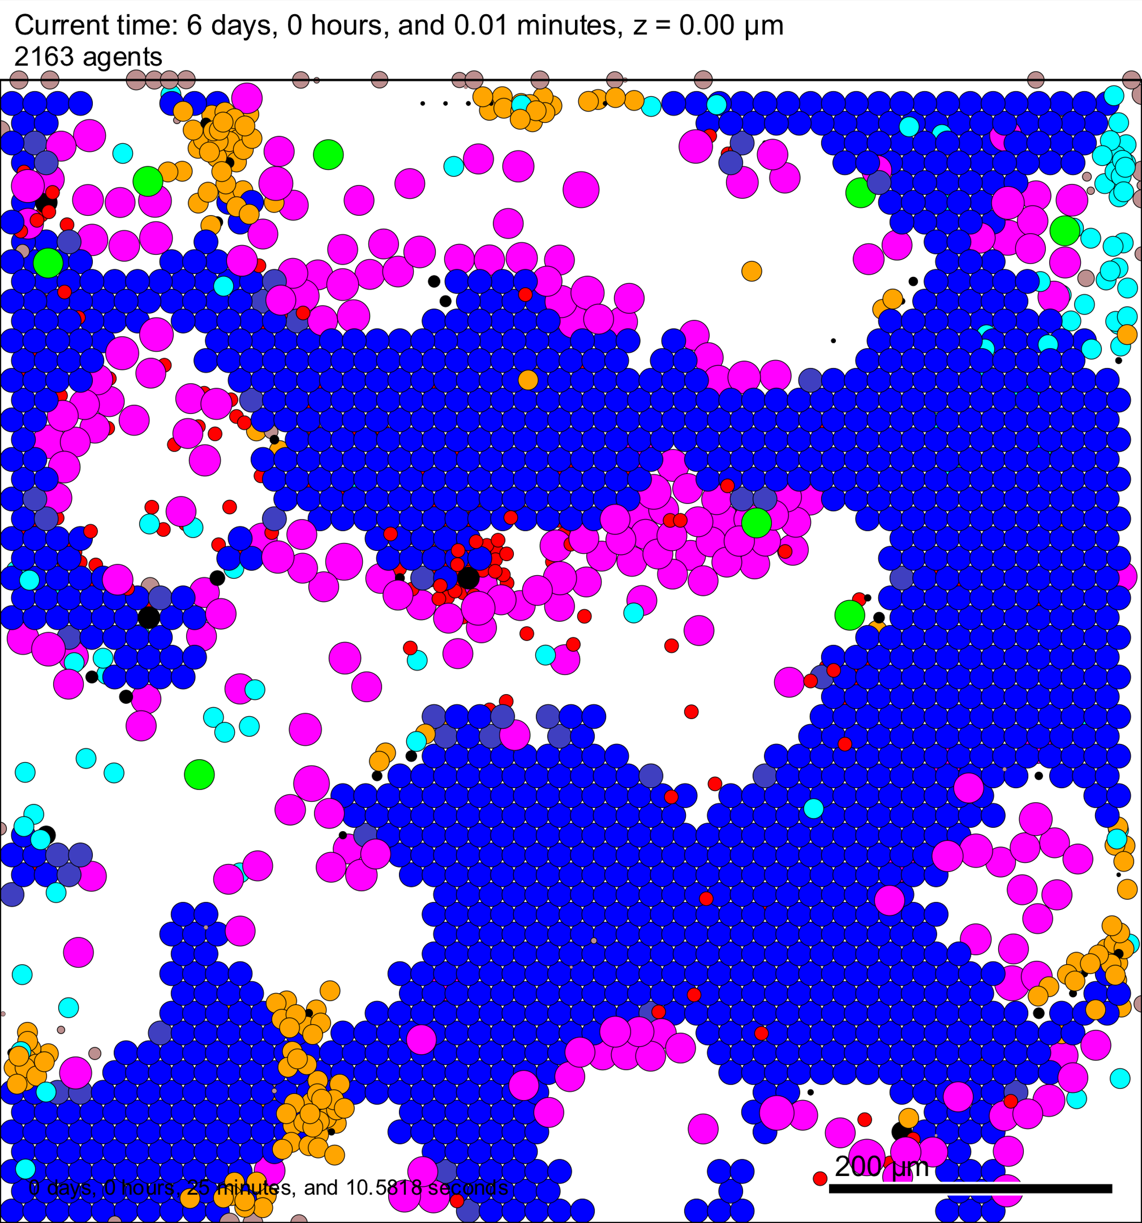 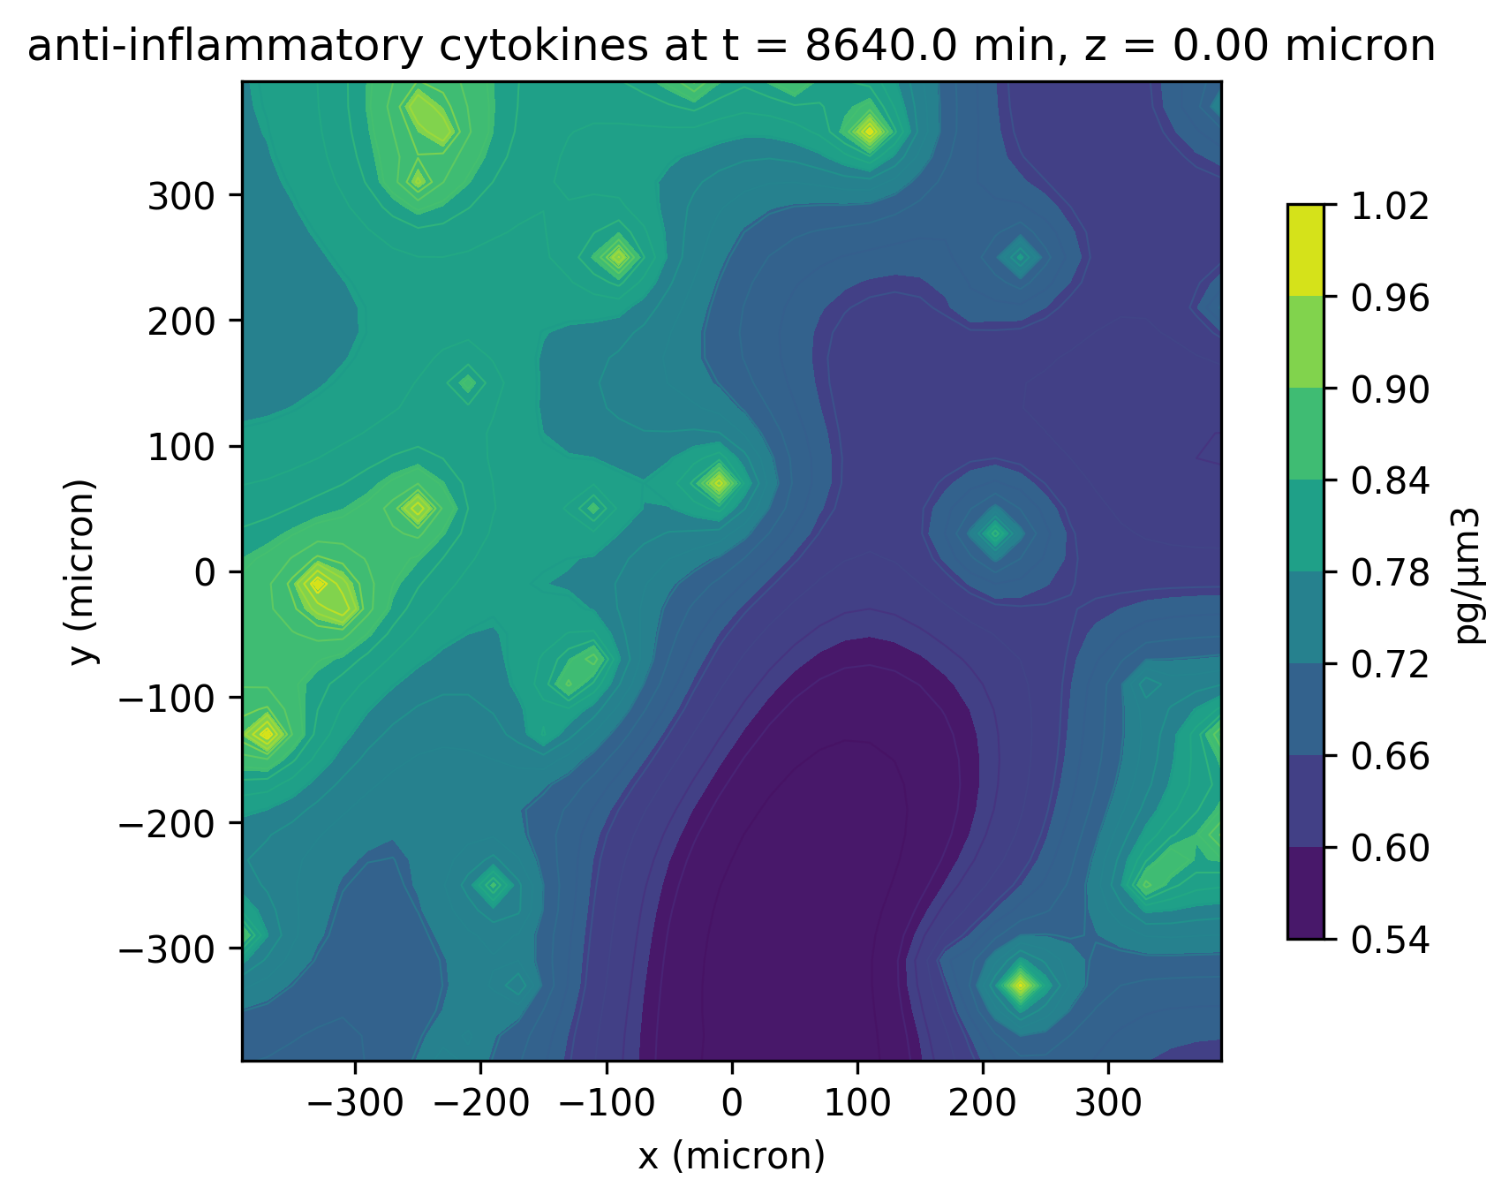

**Setting anti-inflammatory secretion rate = 10**

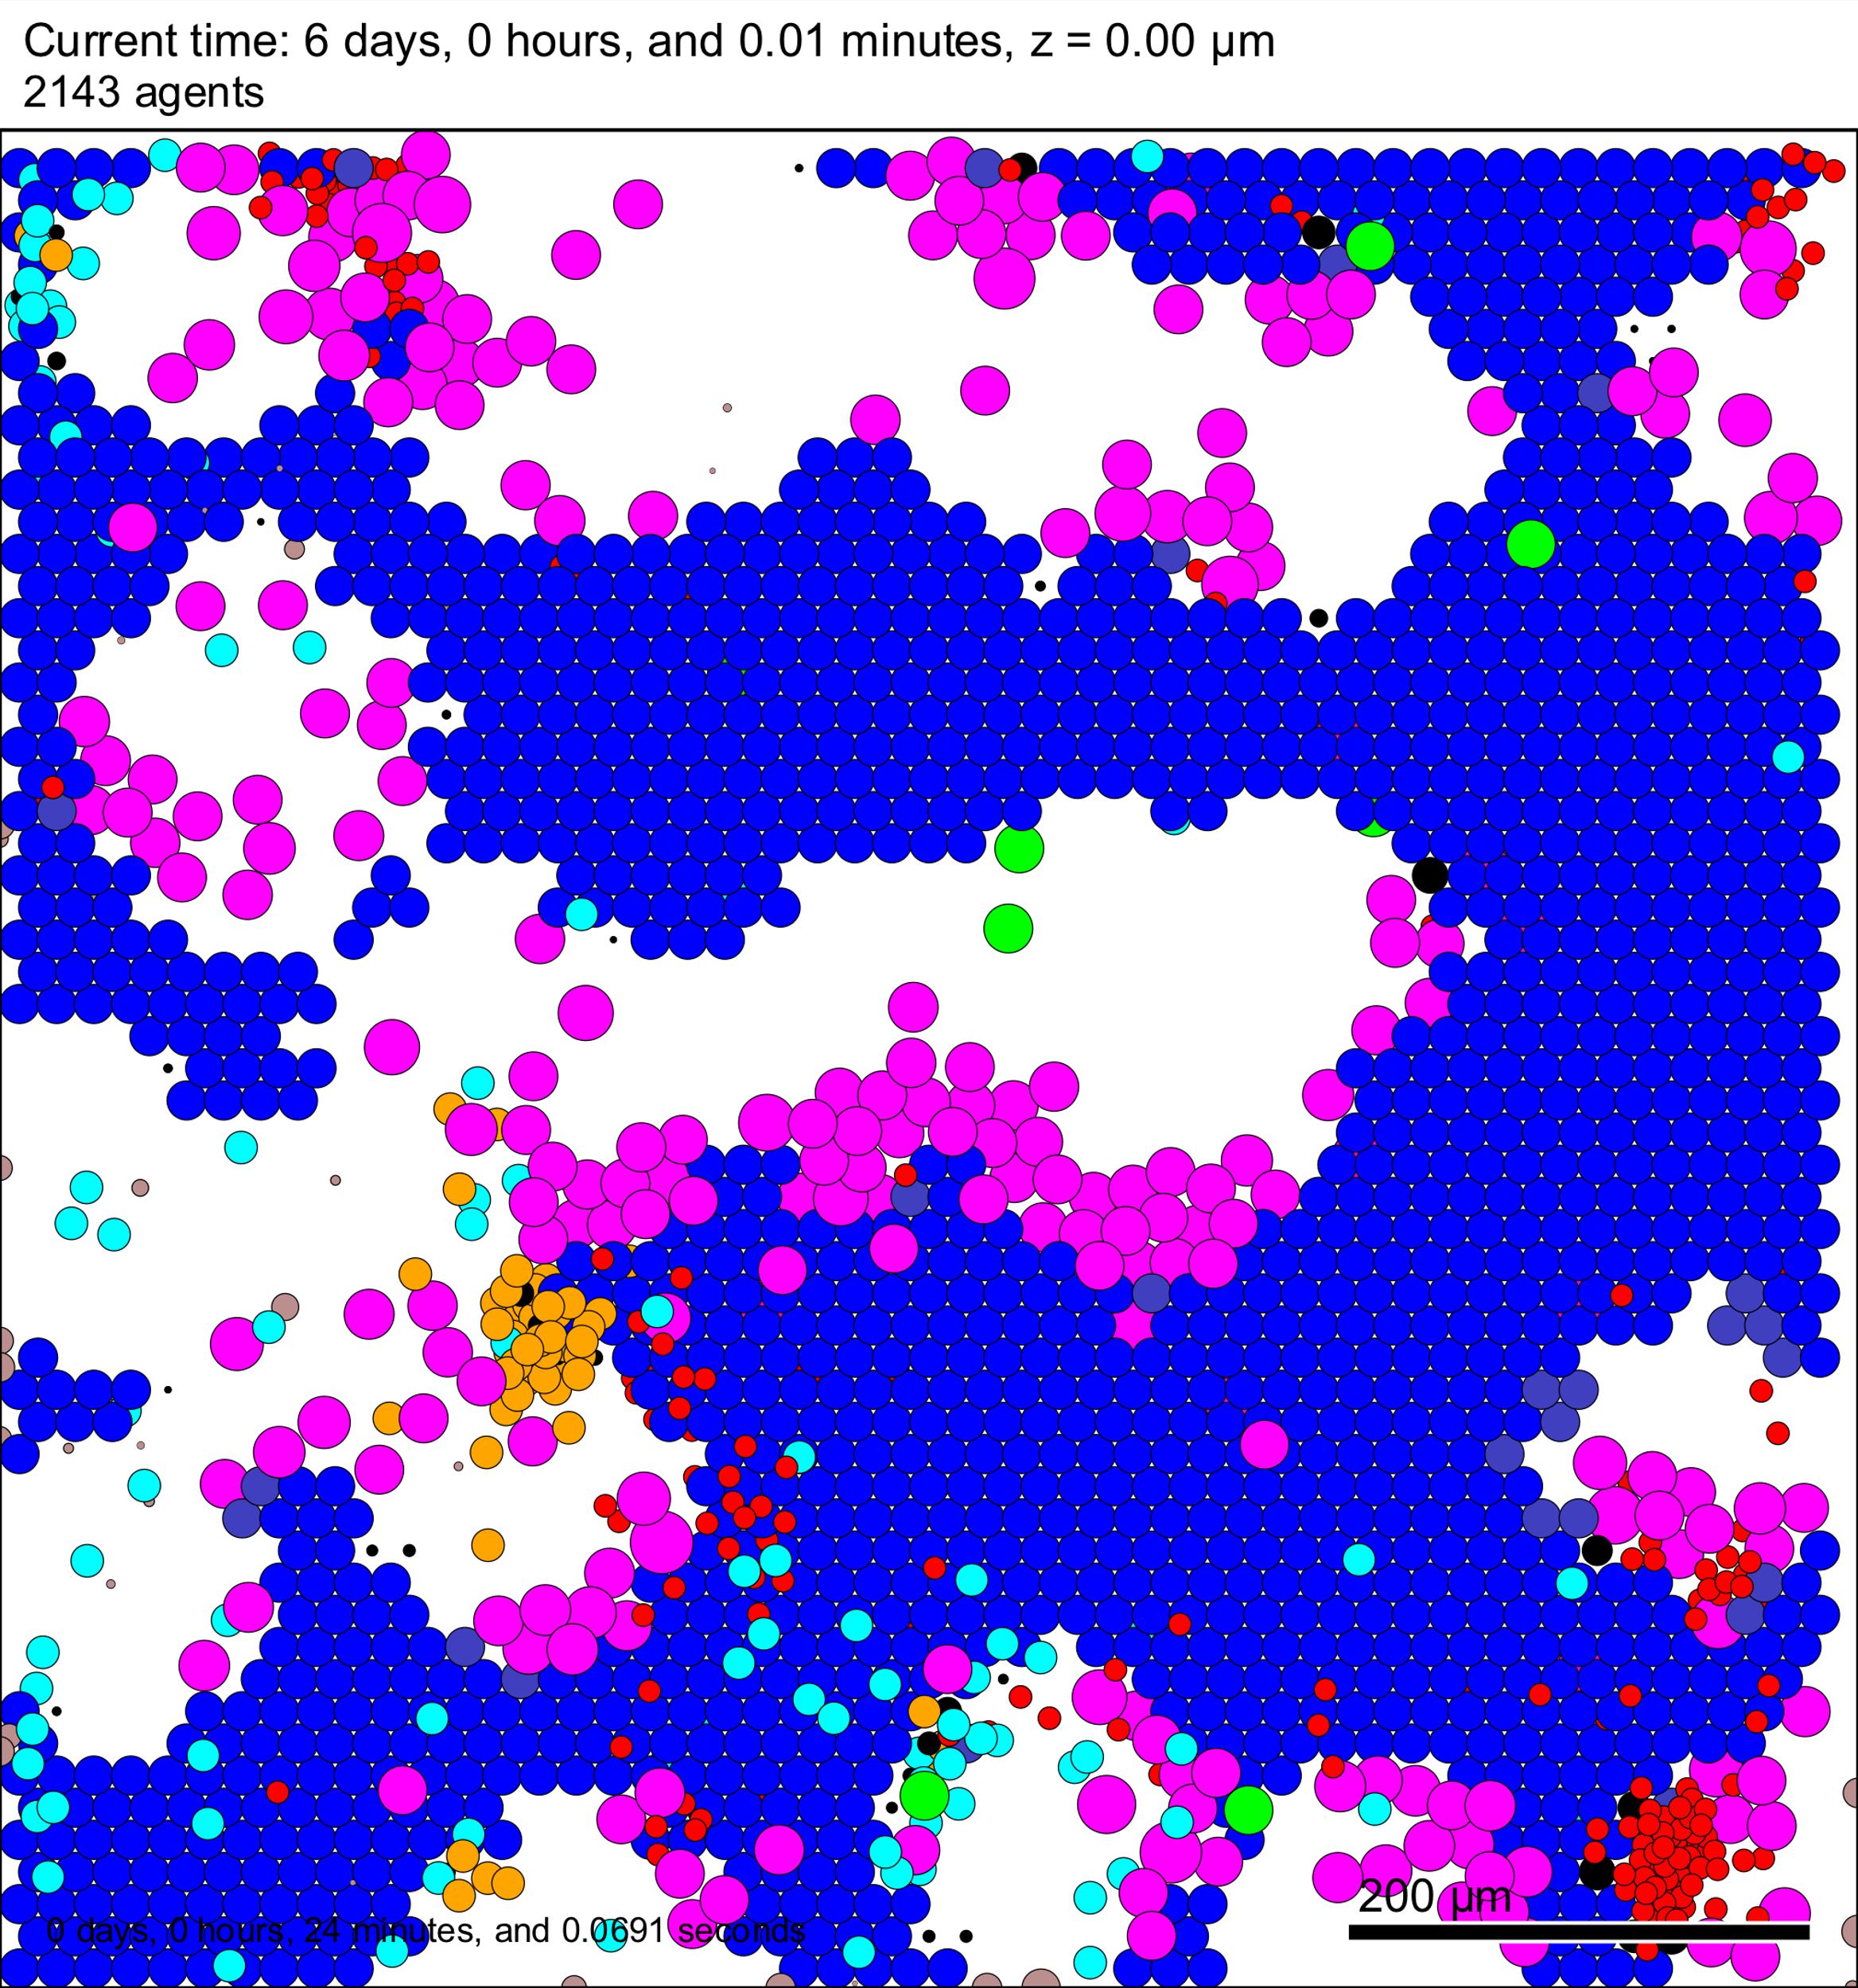

**In immune_submodels.cpp line 412,** I set phenotype.motility.is_motile = true. Added other function for fibroblast and anti-inflammatory cytokines. The parameter values are added in PhysiCell_settings.xml file. But not sure whether this command will automatically add the anti-inflammatory cytokine gradient for fibroblast motility (find no direct connection in code file).